**Drug inventory management system**

1. **Introduction**

Managing pharmaceutical stock is a critical aspect of health service delivery, especially in hospital clinics and pharmacies, inadequate drug inventory control can lead to shortages, overstocking or the us f expired medicines al o which ending patients health and increase operational costs [1],[5]. The project proposes the development of a drug inventory management system designed to automate and properly streamline the process of managing drug inventory in health facility

1. **Problem statement**

Many clinics and pharmacies in a a resource limited setting rely on a manual or semi - automated methods for inventory tracking and management. Hese methods are prone to man error, and real-time updates, and are inefficient in alerting the responsible about critical issues like stock depletion expiration [2],[3]. The proposed system aims to resolve these challenges by offering a digital solution that improves efficiency, reliability and safety.

1. **Objectives**

* To develop a web-based application for managing drug inventory in a health
* Facility
* To implement features for tacking stock levels , expiry dates and generating
* alerts for expiring drugs and low tock.
* To enhance data accuracy and accessibility through a user- friendly interface
* To ensure clear demonstration of OOP principles ie encapsulation, inheritance, abstraction and polymorphism

1. **Methodology**

The system was developed using an agile software development approach to enable iterative progress. Continuous feedback and flexibility in addressing user requirements .

The key technologies and tools used include:

Frontend: HTML and CSS

Backend: python with flask

1. System Architecture

Componens within the system

* app.py :this acts as the main application controller
* models/ : this houses classes for drugs, users and inventory
* templates/ : this holds the html templates for the user interface

1. **implementation**

**front end:** this has the login form simulating user access, the dashboard to view drug inventory and also forms for adding drugs, stocking in and viewing low stock drugs

**backend:** this handles drug registration and management, stock in/out operations, expiry date validation low stock filtering and user role simulation using OOP

Key classes:

* **Drug:** attributes include name, type, batch number, expiry date and quantity. This demonstrates encapsulation and abstraction
* **User and pharmacist** this demonstrates inheritance and polymorphism through methods like get_role()
* **Inventory**: this manages drug in memory; supports add, retrieve and list operations

**Results**

The system allows

* Drug registration and inventory updates
* Expiry and low stock alerts
* Simulation of hamacist roles
* Efficient use of op cncept and olar python code

Back end implementation was done using flasks shown below

**Drug.py**

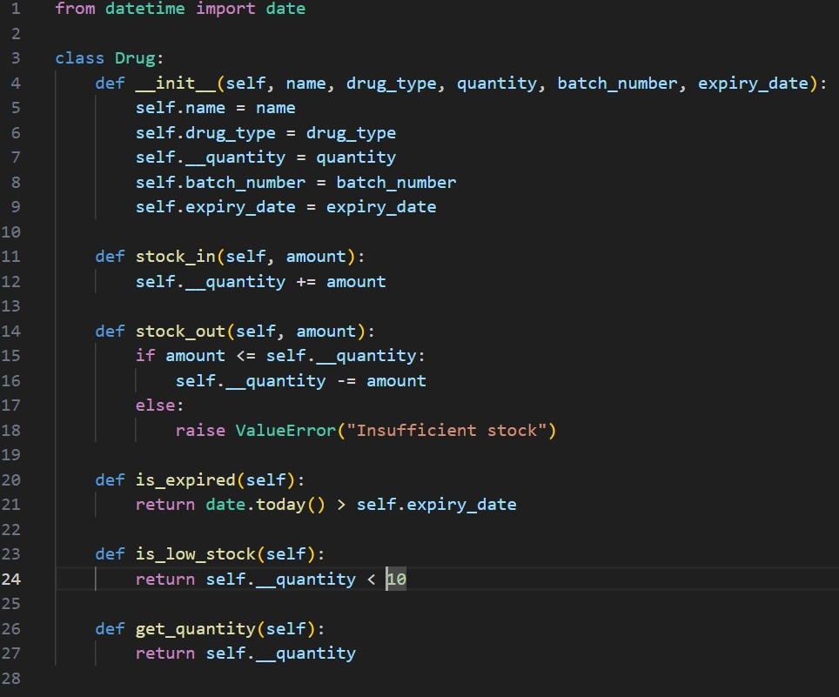

Inventory.py

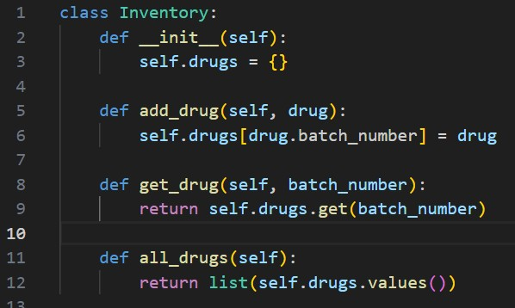

User.py

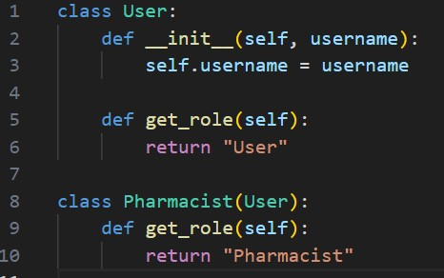

Flask app implementation

The main logic of the system is in app.py which routes requests to the appropriate functions and views

For example, a route for /add_drug

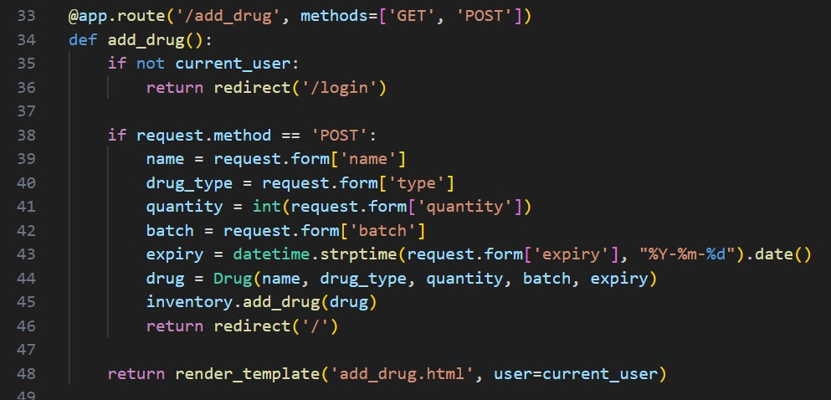

/stock_out

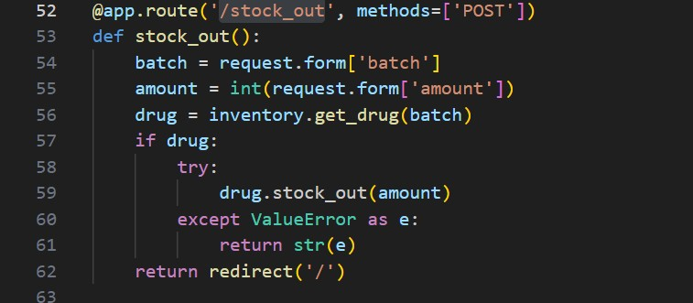

Below is how the system functions in the front end

Login in screen

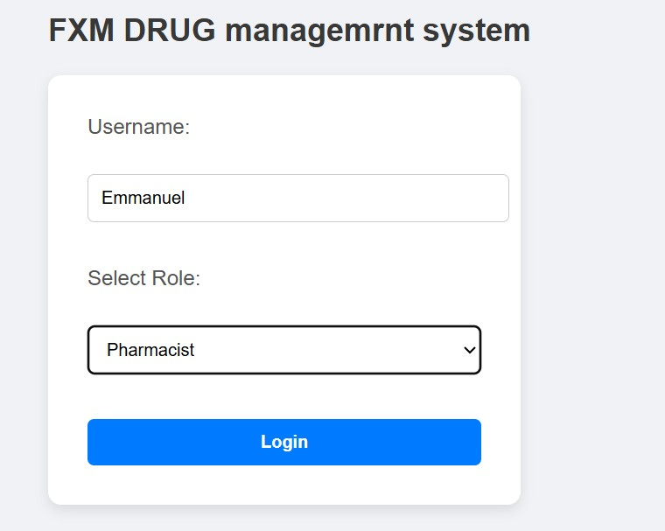

Adding new medicine

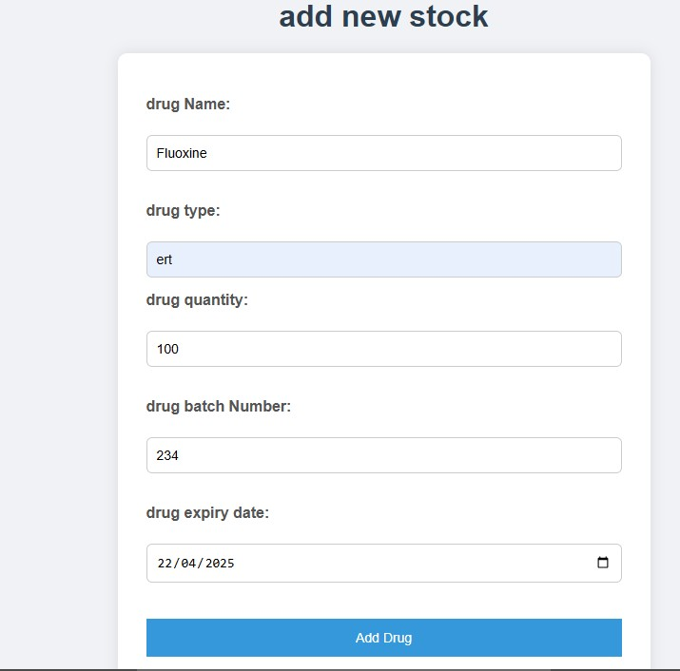

Added stock

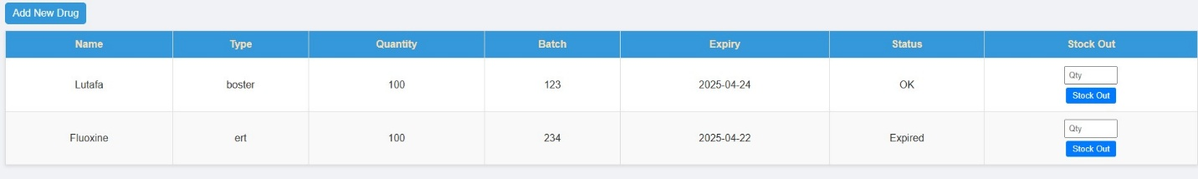

Add stock in to already existing

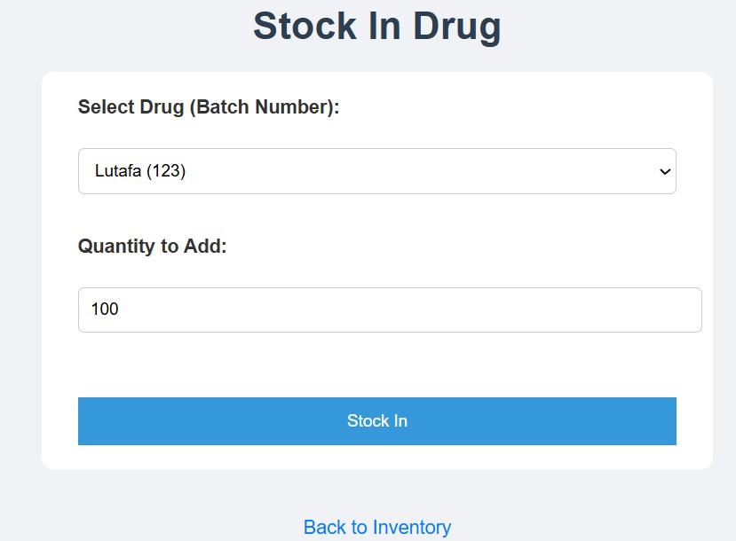

Viewing medicine with low sock after giving out some

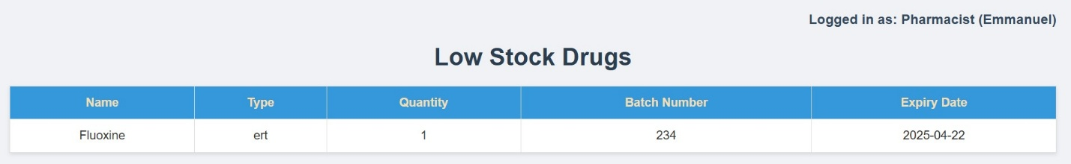

Up fluoxine has been deducted by 99

Below is where stock is given out and it also shows the expired stock

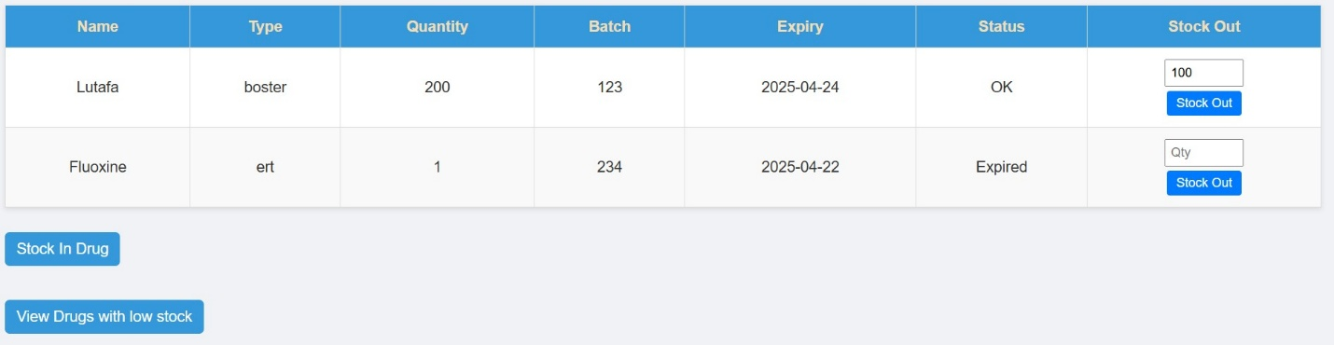

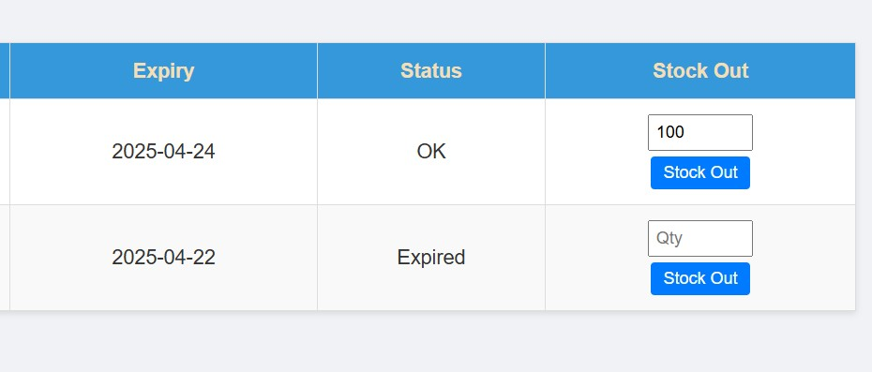

When you observe the above 2 figures you see that fluoxine is expired

Also, in the last column is where stock outs are made.